Install mongodb and compass. Video: https://www.youtube.com/watch?v=IC_ik7wE6eM

Login to local through compass.

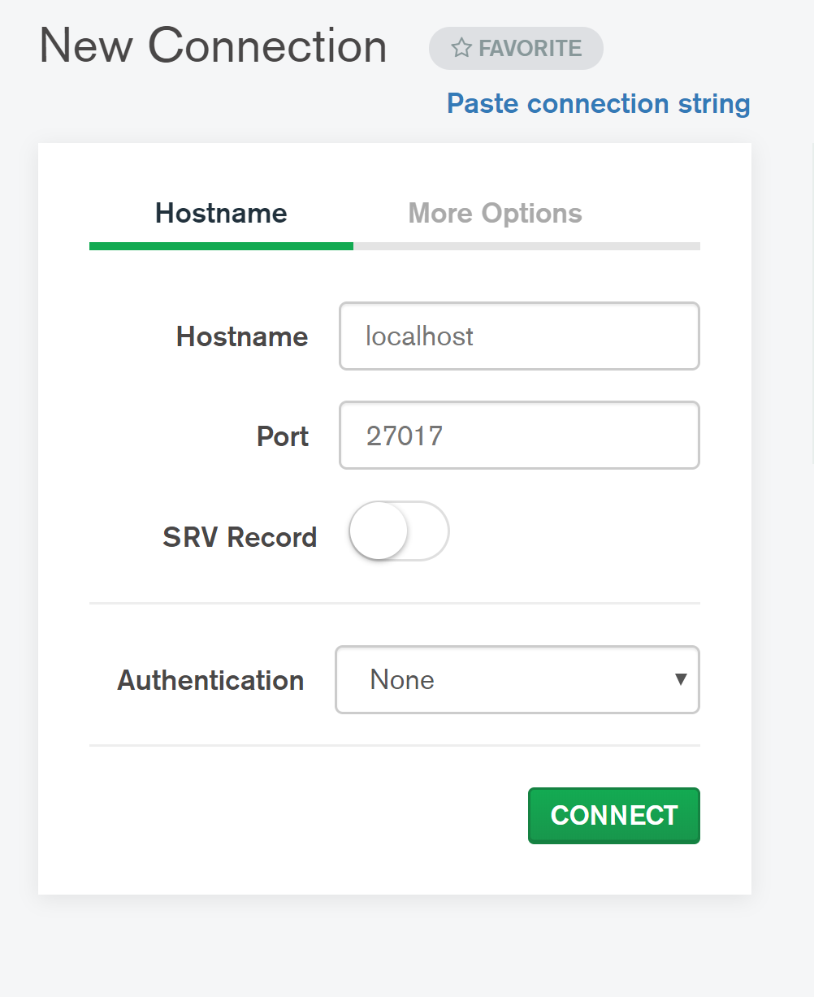

Create a Database called 480DataBase

Create a collection called ”Top2010-19”

Import the csv file called top10s

Change the imported values to numeric, where the values are numbers

Install node.js (follow instructions given by the professor)